# Aloysius Alfa Purnomo Assignment Part 2

## Iteration 3

* Focus:
  + add capability to change the status bar according to the status broadcasts
* Verification:
  + Try playing the game
  + Check whether the status bar is correct
  + Try winning the game
  + Check whether the status bar is correct for all user
* Progress:
  + The status bar now shows the correct text

|  |  |  |  |
| --- | --- | --- | --- |
| **Function Name** | **Description** | **Input** | **Output** |
| App() | Constructor of app class. Creates mainwindow instance with respective handlers | - |  |
| HandleSetNetworkMenu | Handle set network information menu | Object, RoutedEventArgs |  |
| AddSetNetworkMenuHandler | Pass the event to the event handler | RoutedEventHandler | - |
| getIP | Return the ip address | - | Check with console.writeline(); |
| getPort | Returns the port number | - | Check with console.writeLine(); |
| portSlider_ValueChanged | Change the value of port number textblock | object, RoutedPropertyChangedEventArgs<double> |  |
| ipTxt_TextChanged | Check the ip address with regex | object, TextChangedEventArgs |  |
| okBtn_Click | Retrieve the ip address and close the window | Object, RoutedEventArgs | Close the window |
| HandleMulticastMenu | Handles and shows multicast window when clicked. Multicast window is network window but with changed default port value | object sender, RoutedEventArgs e |  |
| HandleLoginMenu | Handles and shows login window when clicked | object sender, RoutedEventArgs e |  |
| HandleMouseEvent | Handle mouse clicks | object,MouseButtonEventArgs | - |
| showpiece | Show ellipse in board | Int, bool | Same with assignment part 1  In assignment part 2 it is not yet implemented |
| setPieceColour | Change the ellipse colour | Int, brush | Same with assignment part 1  In assignment part 2 it is not yet implemented |
| AddMouseHandler | Pass mouse click event | MouseButtonEventHandler | - |
| HitTest | Get row and column position of where the mouse clicked | Point |  |
| getRow | Returns row number | - | Row number |
| getCol | Returns column number | - | Column number |
| connectTo | Connect to server | String, int | - |
| sendRequest | Handle requests sent from controller | string | - |
| getResponse | Return the response string | - | Request string |
| Board | Handles the game and move logic | - | - |
| resetBoard | Set pieces to initial state | - |  |
| IsValidMovePlayer1 | Check valid moves for player 1 | string | True or false |
| IsValidMovePlayer2 | Check valid moves for player 2 | string | True or false |
| isP1Win | Check whether player1 wins | - | True or false |
| isP2Win | Check whether player2 wins | - | True or false |
| Move | Move piece | String, string, Piece | Piece is moved |
| GetPieces | Return the notation of all pieces in board | - |  |
| App() (Server) | Controller of the mainwindow of the server | - |  |
| HandleNetworkSetupMenu | Handles and show network setup window | object sender, RoutedEventArgs e |  |
| HandleMulticastMenu | Handles and show modified network setup window | object sender, RoutedEventArgs e |  |
| HandleListViewItem | Check whether the clicked item is listviewitem. If yes, get the content and send request | object sender, System.Windows.Input.MouseEventArgs e |  |

Changing status









UML Diagram

Client

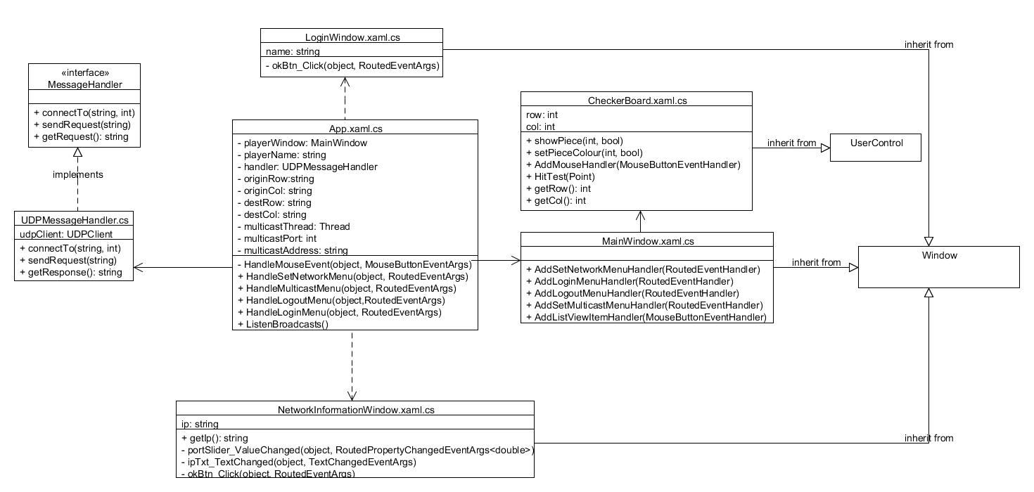

Servers 